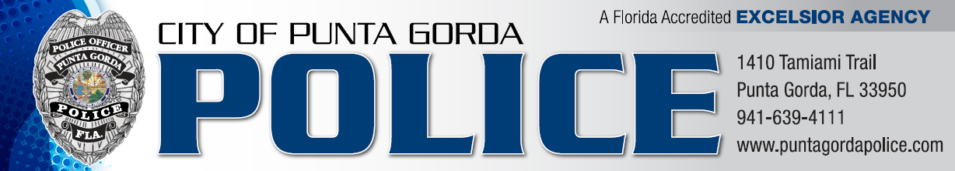
NEWS RELEASE

March 7, 2016

Punta Gorda Police Canine Unit
Impresses at Regional Canine Trials

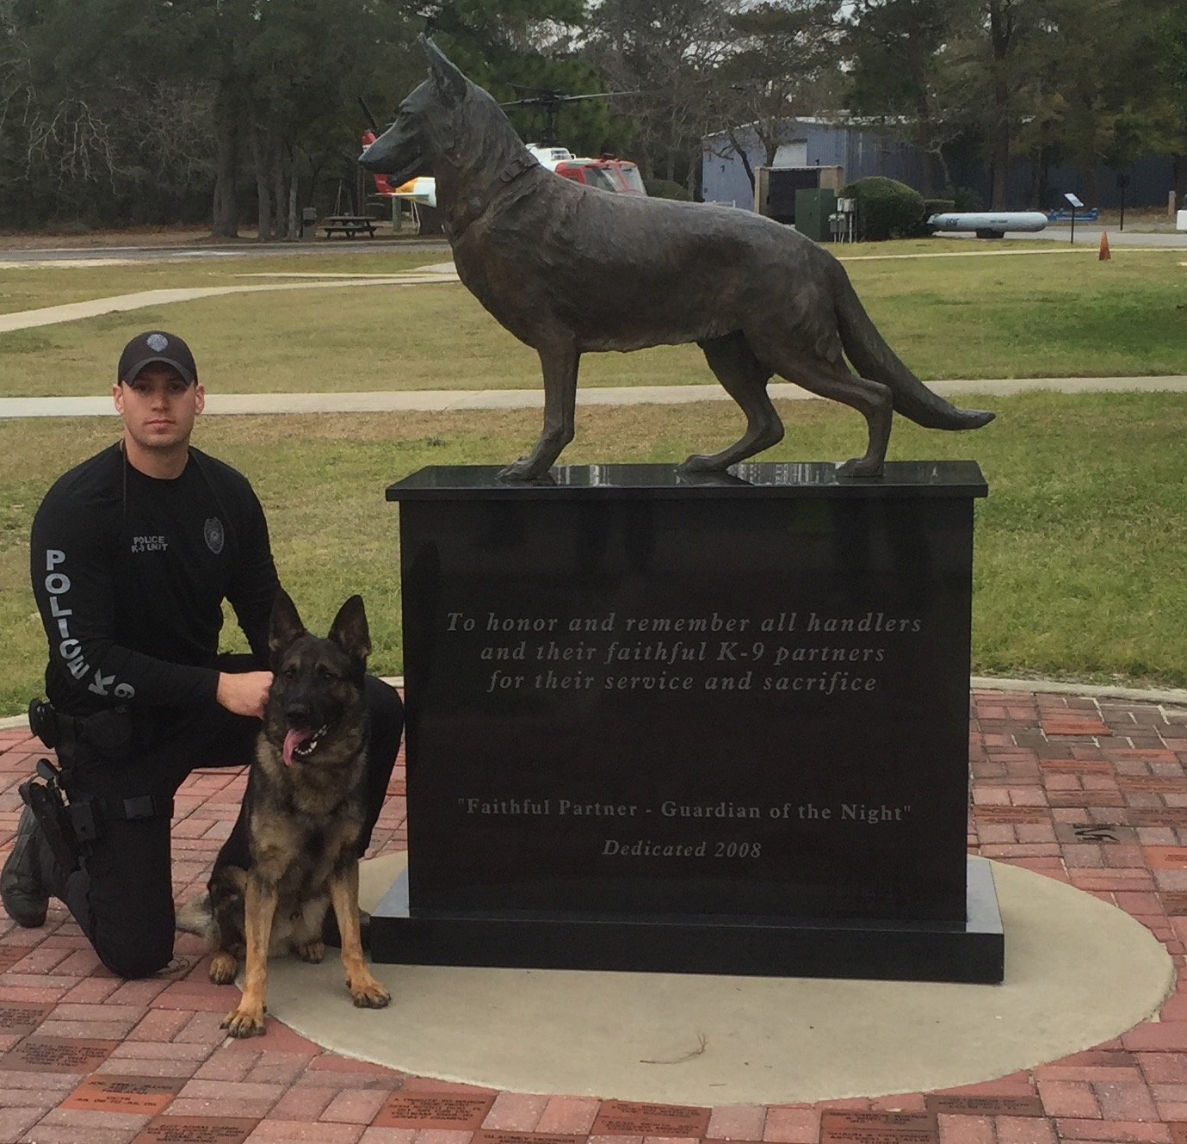
The Punta Gorda Police Department Canine Team of Officer Lee Coel and Canine Spirit competed at the United States Police Canine Association (USPCA) Region One Canine Trials in Walton County, Florida last week. A total of 64 canine teams from across the state took the field in hopes of not only maintaining state-mandated certifications, but returning to their community with recognition for a job well done. Our Punta Gorda team accomplished both of these goals.

Lee and Spirit placed 17th in the overall competition, 3rd place in narcotics detection (vehicles), and 2nd place in the Two-man Team Competition (Punta Gorda teamed with Highlands County as a two-man team).

Officer Coel stated, “The Punta Gorda community has made an investment in Spirit and our canine program. We are proud to bring back these trophies to our community in recognition of all the support we have received from our City.”
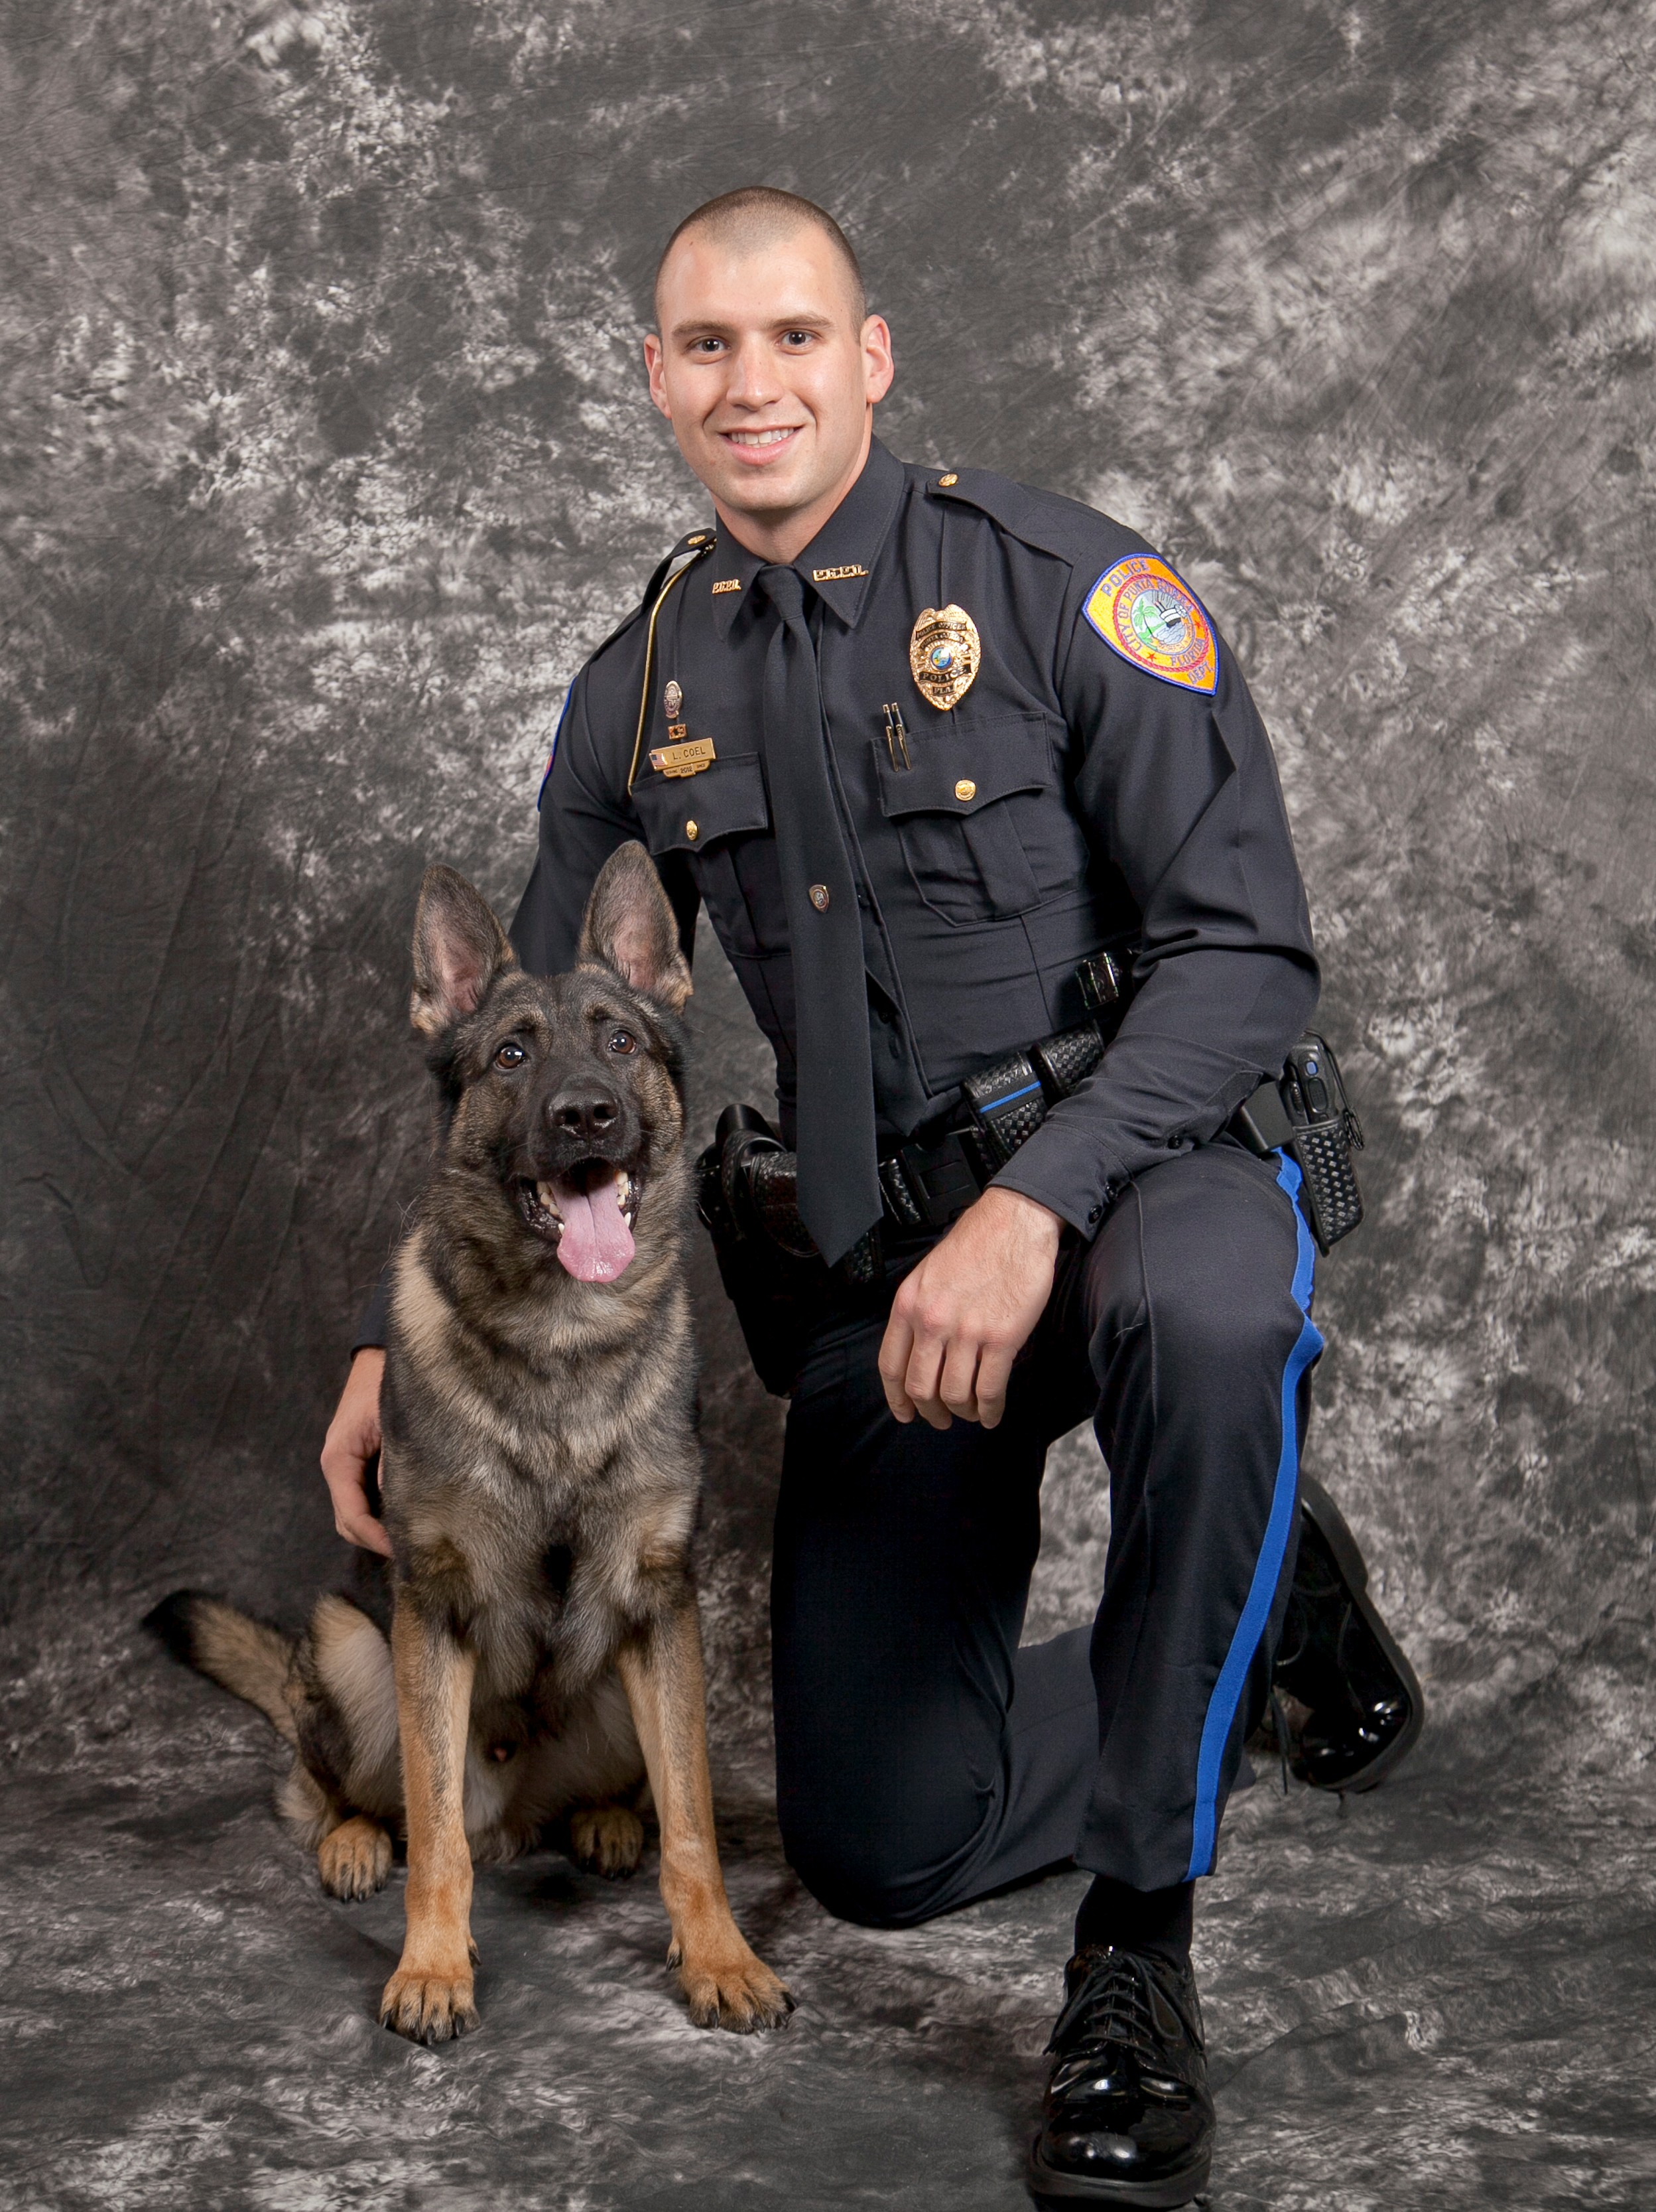
Canine Spirit was acquired by the Punta Gorda Police Department on May 14th of 2014. After entering a training program as required by the Florida Department of Law Enforcement, Spirit was certified in narcotics in August 2014 and certified in patrol in September of 2014. Spirit was officially designated as a Punta Gorda Police Officer on September 24, 2015.

“We are extremely proud of Lee and Spirit,” stated Interim Chief Tom Lewis. “Their performance demonstrates not only their proficiency, but also their dedication to training and providing quality service to the citizens in Punta Gorda.”

Prepared by:
Lieutenant Katie Heck
Punta Gorda Police Department
(941) 575-5525
kheck@pgorda.us

