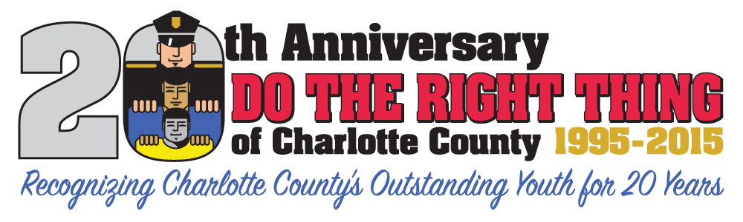
The Punta Gorda Police Department is pleased to recognize five Charlotte County youth as part of the Do the Right Thing of Charlotte County’s monthly program.
The first recipient is Marissa Oliva, the daughter of Erin Porter and Richie Oliva. Marissa is in the 4th grade at Mayakka Elementary School.
Marissa took on a project which makes us at the PD feel very happy. It is also a project that is very dear to her; the widows and orphans of deceased Police Officers fund. Marissa was deeply affected by the murders of the two NYPD Officers this past January. Having a grandfather that is a disabled NYPD Police Officer, who was injured in the line of duty, Marissa wanted to do something special. She is making and selling Paracord Thin Blue Line Bracelets, with the proceeds being donated to the Anchor Club of the NYPD widows and orphans fund. To date she has raised close to $2,000.00 and is still working to raise more money.

For many of you, the concept of a Thin Blue Line bracelet may be ambiguous. The term thin blue line represents the police between the community and the criminals. The black field at the top is representative of the community and the black field at the bottom, the criminals. The blue line separating them stands for the police who are dedicated to make certain that the community is protected from criminals. Marissa is selling a bracelet which depicts this concept.

Marissa, thank you so much for caring about the feelings of others, especially the widows and orphans of deceased police officers. Unfortunately, there is hardly a week that goes by that we don’t read of another police officer who loses his or her life in the line of duty. We appreciate your thoughtfulness.

In addition to caring about others, Marissa loves softball and is part of the girls on the run a leadership program. She is also in the school chorus. In her spare time she likes to read, write and work on crafts. She gets straight A’s in school , and she has also been a Girl Scout.

Our next young recipients for this month are a pair of second graders. The first is Brooke Kirkland, a second grader at Neil Armstrong Elementary School. Brooke, is the daughter of Colleen and Kenneth Croyle. The second is Joseph Hrigora, also in Neil Armstrong’s second grade and the son of Carrie Marks and Jaret Hrigora.

These two second graders became concerned when they observed another child in school carrying a knife. Knowing that the possession of a knife could be a dangerous situation for not only the person with the knife, but possibly others, they immediately informed the principal. Brooke and Joseph told the principal that another student had a knife in their back pack. The principal, Angie Taillon, stated that she was very proud of both Brooke and Joseph for reporting this unsafe situation to her. This took courage! Taillon stated “I am very proud of them for standing up for what is right and doing the right thing! “

Brooke and Joseph, we too are proud that you recognized that something wrong could have happened if you didn’t inform your principal of your observations. Thank you for your concern.

In her spare time, Brooke loves video games and doing anything outdoors. She also loves to go bowling. She has an interest in art, especially painting and also makes clothes for her dolls. Brooke is also very active in her church and gets very good grades in school.

Joseph is into Legos and recycling. He supports the vets, loves to travel and loves animals and also gets very good grades in school.

Zoey Goodman is the next person DTRT of Charlotte County would like to recognize for April 2015. Zoey is a fourth grader at Meadow Park Elementary School and is the daughter of Candice Goodman

Zoey was nominated by the Commander of the local Disabled American Vets chapter who wrote: Zoey has been doing volunteer work for the Disabled American Veterans, Robert L. Cochran Chapter 82, Port Charlotte, for the past year or more. She volunteered for the Golden Coral fund raising weekend this past Veterans Day, she also volunteered to work the Stone Crabs DAV Appreciation day fund raiser at the ball park, and several other events through the past year. Zoey shows the true spirit of volunteerism. That is why it was decided to nominate Zoey for the Do The Right Thing award. For her age she has been very instrumental in our fund raising events. Zoey is always willing and excited to help our Chapter, and we sincerely appreciate her hard work

Wow, a fourth grader with that level of commitment. I am impressed. Zoey, thank you so much for caring about others as much as you do. We are very proud of you as well.

In addition to the Disabled American Vets volunteer work, Zoey has also been involved with the Toys for Tots program. She likes scrap boarding and making jewelry and gets mostly A’s and B’s in school.

Our last DTRT recipient for April 2015 is a young man by the name of Jake Guarino. Jake is in the 8th grade at the Charlotte Academy and is the son of John and Maureen Guarino.

Jake is a very caring and generous person. He inherited some money from his Great Grandmother, who passed away in May of 2013. Upon receiving this money, he decided to donate $100 to the local Special Olympics program. Being a young athlete, he wanted to make sure others could enjoy playing sports as much as he does. I find it interesting to know that the decision to donate the money to Special Olympics came after Jake was in the audience watching a Punta Gorda Police Department game where some of our officers played the Charlotte County Special Olympics kids.

Jake, we are very proud of you and the fact that you were thinking of others and their enjoyment, especially those who might be in need of some additional support. Congratulations.

Jake is very involved in flag football and basketball. He gets good grades in school and loves to sail. He is also very interested in raising fish in his fish tank. Jack has also been involved in the YMCA family programs.

The Punta Gorda Police Department will be recognizing all of the 2014-2015 school year winners at a special event on May 14, 2015 at the Charlotte Harbor Event Center in Punta Gorda, Florida at 2:30 PM. At that time, an overall winner for the year will be announced for the elementary, middle school and high school levels. PGPD welcomes the attendance of other Law Enforcement agencies and their officers at this special event. Please RSVP to Corporal Pribble at apribble@pgorda.us.

We always like to hear about all of the wonderful things our youth are doing in our communities. If you know of a student in Charlotte County doing good deeds please nominate them for a Do the Right Thing award at www.puntagordapolice.com or call the Executive Director of Do the Right Thing of Charlotte County, Corporal Tony Pribble at 941-639-4111.

Submitted by L. Schrader
Punta Gorda Police Department
941-639-4111

