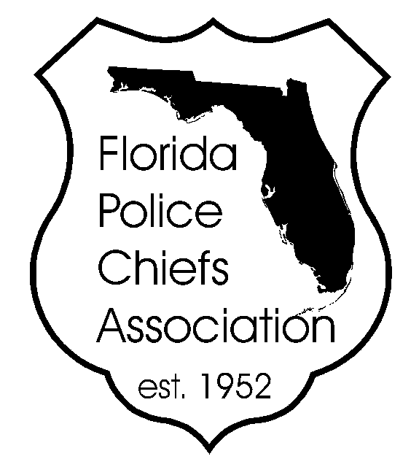

FLORIDA POLICE CHIEFS ASSOCIATION

Gain extra exposure for your company
by becoming a FPCA “Conference Sponsor”

Corporate Sponsors and their contributions make all of the special events at the conferences possible. Without our Corporate Sponsors we would be unable to fund a variety of conference activities. We are in the process of scheduling activities and would like to invite you to sponsor an event and obtain special recognition as a FPCA Sponsor. As you are aware, corporate sponsorships are needed now more than ever with the budget issues affecting local government. Show your support today by becoming a FPCA Sponsor. For more information contact us at (850) 219-3631.

Platinum Sponsor - $15,000

- Plaque presentation at the Summer Conference or Conference
- Special recognition at sponsored event
- Special recognition in Vendor and Member Conference packets
- Speaking opportunity at one of the FPCA yearly conferences (10 minutes)
- Special tribute in FPCA enewsletter (Florida Chiefs Connection)
- Listed as a platinum sponsor on FPCA Web page
- One-year free logo banner and ad for your Company on the FPCA Buyers Guide
- Two Complimentary tickets to the Installation & Awards Banquet or Winter Meet & Greet
- Full-page ad in the conference program guide
- Banner displayed near conference registration desk throughout exposition (company provides)

Gold Sponsor - $8, 000

• Special recognition at sponsored event
• Special recognition in Vendor and Member Conference packets
• Special tribute in FPCA enewsletter (Florida Chiefs Connection)
• Listed as a gold sponsor on FPCA Web page
• One-year ad free for your Company on the FPCA Buyers Guide
• FPCA certificate of appreciation
• Half-page ad in the conference program guide

Silver Sponsor - $5,000

• Special recognition at sponsored event
• Special tribute in FPCA enewsletter (Florida Chiefs Connection)
• Special recognition in Vendor and Member Conference packets
• Listed as a silver sponsor on FPCA Web page
• FPCA certificate of appreciation

Sponsor Form
Page 2

Bronze Sponsor - $2,000

• Special recognition at sponsored event
• Special recognition in Vendor and Member Conference packets
• Listed as a bronze sponsor on FPCA Web page

PLEASE NOTE: Sponsorship commitment does not include registration fee or booth space. To participate on site during the conference, sponsors are required to purchase booth space. Please contact FPCA at (850) 219-3631 for information on booth availability.

I PLEDGE AND AGREE TO SPONSOR $ _____________________

EVENT YOU DESIRE TO SPONSOR:
Hospitality Suite, Host Chiefs Night, Golf Tournament, Spouse Program, Youth Program, Transportation, etc.

___________________________________________________________________________________________________

__________________________________________________________________________________________
COMPANY NAME CONTACT PERSON PHONE

__________________________________________________________________________________________
SIGNATURE DATE

Submit to:
Southwest Florida Police Chiefs Association
Attn: Chief John “Jack” T. Cavanaugh, Jr.
Lee County Port Authority P.D.
11000 Terminal Access Rd. Ste. 8671
Fort Myers, FL 33913
239- 590-4771

