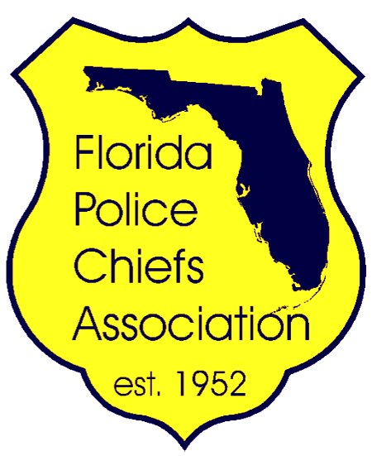
The Florida Police Chiefs Association
64th Annual Summer Training Conference & Expo
Hosted By: Southwest Florida Police Chiefs Association

The Florida Police Chiefs Association (FPCA) is holding its 64th Annual Summer Training Conference and Exposition at the Hyatt Regency Coconut Point in Bonita Springs, Florida from July 29 to August 2, 2016 and its being hosted by Southwest Florida Police Chiefs Association (SWFPCA).

The FPCA was established in 1952 and is the third largest police chiefs association in the United States. It is composed of more than 900 members who represent Florida’s top leaders in law enforcement. We anticipate approximately 250 police executives will attend this conference. There will also be approximately 120 companies exhibiting their latest technology, products and services.

The SWFPCA is planning several events that will showcase our local communities and area attractions. Therefore, we must obtain sponsorships to offset expenses.
Sponsorships will be accepted by the SWFPCA and checks should be made payable to the SWFPCA and forwarded to, Chief Jack Cavanaugh, Lee County Port Authority Police Department, P.O. Box 1209 Fort Myers, FL 33902.

If you would like to participate as a vendor at the conference, the purchase of a booth is required and is not included in the donation. The booth layout, exhibit rules and booth registration form is available on the FPCA’s website at www.fpca.com.
Included with this letter, is a form that outlines sponsorship levels and details recognition opportunities for sponsors. You may contact FPCA’s Membership & Conference Manager, Tammy Agee at 850-219-3631, or by email at tagee@fpca.com for additional information. You may also call me at 239-462-9858, or by email at jtcavanaugh@flylcpa.com.
On behalf of our members, we appreciate your consideration of this request.

Sincerely,

Chief John “Jack” Cavanaugh, Jr.
President
Southwest Florida Police Chiefs Association

